Smart ML-Based Health Disease Prediction and Assistance System
A Project Report submitted in partial fulfillment of the requirements for the award of the degree of

Bachelor of Technology
In
Computer Science & Engineering

Submitted by
M. DEEPAK 226C1A0567
M. DINESH 226C1A0568
P. ESWAR KUMARI 226C1A0595
P. MAVULLU 226C1A0593

Under the Esteemed Guidance of
Mr. K. Sukesh Kumar
Assistant Professor, Dept. of CSE


MIRACLE EDUCATIONAL SOCIETY GROUP OF INSTITUTIONS

(Autonomous)
(Approved by AICTE, New Delhi & Affiliated to JNTU-GV) Miracle City, Munjeru village, Bhogapuram, Vizianagaram-535216
(2022-2026)

CERTIFICATE

This is to certify that the project report entitled “Smart ML-Based Health Disease Prediction and Assistance System” submitted by M. Deepak (226C1A0567), M. Dinesh (226C1A0568), P. Eswar Kumari, and P. Mavullu (226C1A0593, 226C1A0595) to the Miracle Educational Society Group Of Institutions, Bhogapuram in partial fulfillment for the award of the degree of B.Tech in Computer Science & Engineering is a bonified record of project work carried out by him/her under my supervision. The contents of this report, in full or in parts, have not been submitted to any other Institution or University for the award of any degree or diploma.

Mr.G.Rajasekharam Mr. K. Sukesh Kumar
Associate Professor, Assistant Professor, Project Guide Head Of the Department

Signature of External Examiner

DECLARATION

We, the undersigned students of the final year B.Tech in Computer Science and Engineering at Miracle Educational Society Group of Institutions (Autonomous), hereby declare that the project report entitled "SMART ML -BASED HEALTH DISEASE PREDICTION AND ASSISTANCE SYSTEM" is our original work and has been carried out by us under the supervision of Mr. K. Sukesh Kumar, Assistant Professor, Department of Computer Science and Engineering. We further declare that this work has not been submitted either in full or in part for the award of any other degree or diploma in this institution or any other institution.

With Sincere regards

M. DEEPAK 226C1A0567
M. DINESH 226C1A0568
P. ESWAR KUMARI 226C1A0595
P. MAVULLU 226C1A0593

ACKNOWLEDGEMENT

We would like to thank Mr. K. Sukesh Kumar, Assistant Professor, Miracle Educational Society Group of Institutions, for his constant encouragement and guidance during this project. He has been a constant source of inspiration and helped me in each step. I express my deep gratitude for his support.
We would also like to thank Mr. G. Rajasekharam, Associate Professor, Head of the Department of Computer science & Engineering, Miracle Educational society Group of Institutions for providing us with the required resources and also encouraging us right throughout the project
I also extend my sincere thanks to Dr. B. Srinivasa Rao, Professor & Dean, and Dr. A. Arjuna Rao, Principal, Miracle Educational Society Group of Institutions, for their unwavering support and cooperation.
We would also like to thank Mr. Prasad V Lokam, CEO of Miracle Software Systems, for providing us with excellent state-of-the-art infrastructure, without which we could never have achieved our goals and targets.
We sincerely thank all the staff members of the Department for giving us their support in all stages of the project work. In all humility and with reference, we express our profound sense of gratitude to our parents who have given their complete support in this regard.
With sincere Regards,

Candidates names and Regd numbers
M. DEEPAK 226C1A0567
M. DINESH 226C1A0568
P. ESWAR KUMARI 226C1A0595
P. MAVULLU 226C1A0593

ABSTRACT
The Smart ML-Based Health Disease Prediction and Assistance System is a comprehensive full-stack healthcare platform designed to leverage artificial intelligence and machine learning for early detection and management of critical diseases. The system integrates eight independent machine learning models capable of predicting Diabetes, Heart Disease, Stroke, Kidney Disease, Liver Disease, Lung Cancer, Breast Cancer, and Hypertension, achieving accuracy rates between 85% and 95% across all models using algorithms including Random Forest, Support Vector Machine (SVM), Logistic Regression, and Decision Trees trained on datasets of 5,000+ patient records each.
The platform is built on a three-tier architecture comprising a React 18 Single Page Application frontend powered by Vite and Tailwind CSS, a Node.js/Express 4.18 backend serving RESTful APIs, and a Python FastAPI machine learning inference service — all connected to a MongoDB NoSQL database. In addition to disease prediction, the system provides a comprehensive vital signs monitoring module covering BMI, blood pressure, heart rate, blood sugar, and body temperature with real-time clinical calculations and historical trend visualization using Recharts.
A medication management module offers drug interaction checking across 50+ common interactions, weight-based dosage calculation, medication reminder scheduling, and refill tracking. A healthcare tools suite further includes a Medical Report Analyzer powered by Google Gemini AI, a Medical Jargon Simplifier covering 1,000+ terms, a Medicine Price Comparator with geolocation-based pharmacy search, and an AI-powered Health Chatbot. Security is enforced through JWT authentication, AES-256 data encryption, bcrypt password hashing with 10+ salt rounds, API rate limiting, and compliance with HIPAA and GDPR standards.

TABLE OF CONTENTS

Description | Page Number
CERTIFICATION | I
DECLARATION | II
ACKNOWLEDGEMENTS | III
ABSTRACT | IV
LIST OF FIGURES | VIII
LIST OF TABLES | IX
ABBREVIATIONS | X
CHAPTER 1
INTRODUCTION | 1 - 3
1.1 Introduction to the Problem | 1
1.2 Problem Statement | 2
1.3 Objectives | 2
1.4 Scope of the Project | 3
CHAPTER 2
LITERATURE SURVEY | 4 - 6
2.1 Related Work | 4
2.2 Existing Systems and Limitations | 5
2.3 Proposed System | 6
CHAPTER 3
SYSTEM ANALYSIS | 7 - 9
3.1 Introduction | 7
3.2 Feasibility Study | 7
3.3 Requirement Analysis | 8
3.4 Use Case Description | 9
3.5 System Constraints | 9
CHAPTER 4 | 10 - 13
IMPLEMENTATION
4.1 Module Implementation | 10
4.2 Backend Implementation | 11
4.3 Code Description | 12
CHAPTER 5
RESULTS AND TESTING | 14 - 15
5.1 Test Cases | 14
5.2 Performance Metrics | 15
CHAPTER 6
SYSTEM ARCHITECTURE | 16 - 19
6.1 Introduction | 16
6.2 Architecture Overview | 16
6.3 System Architecture Diagram | 17
6.4 Components of the System | 17
6.5 Data Flow in the System | 18
6.6 Advantages of the Architecture | 19
CHAPTER 7
TOOLS AND TECHNOLOGIES | 20 - 25
7.1 Frontend Technologies | 20
7.2 Backend Technologies | 21
7.3 Machine Learning Technologies | 23
CHAPTER 8
SYSTEM FEATURES | 26 - 30
8.1 Disease Prediction Module | 26
8.2 Vital Signs Monitoring Module | 28
8.3 Medication Management Module | 29
8.4 HealthCare Tools Suite | 29
CHAPTER 9
UML DIAGRAMS | 31 - 35
9.1 Use Case Diagram | 31
9.2 Class Diagram | 32
9.3 Sequence Diagram | 33
9.4 Activity Diagram | 34
9.5 System FlowChart | 35
CHAPTER 10 | 36 - 42
SYSTEM OUTPUTS
10.1 Introduction | 36
10.2 User Authentication Output | 37
10.3 Disease Prediction Ouput | 38
10.4 Vital Signs Monitoring Output | 39
10.5 Medication Management Output | 41
CHAPTER 11
BENEFITS AND HOW TO USE | 43 - 45
11.1 Benefits of the System | 43
11.2 How to use the System | 44
CHAPTER 12
CHALLENGES | 46 - 48
12.1 Technical Challenges | 46
12.2 Design and UX Challenges | 47
12.3 Security and Compliance Challenges | 48
CHAPTER 13
CONCLUSION & FUTURE WORK | 49 - 50
13.1 Conclusion | 49
13.2 Future Enhancements | 50
APPENDIX | 51
BIBLIOGRAPHY | 54
REFERENCES | 55

LIST OF FIGURES

Figure No. | Title | Page
Figure 6.1 | System Architecture Design | 17
Figure 9.1 | VitaCore Use Case Diagram | 31
Figure 9.2 | VitaCore Class Diagram | 32
Figure 9.3 | VitaCore Sequence Diagram | 33
Figure 9.4 | VitaCore Activity Diagram | 34
Figure 9.5 | VitaCore System Flowchart | 35
Figure 10.1 | VitaCore AI Landing Page | 41
Figure 10.2 | VitaCore AI Disease Prediction Page | 41
Figure 10.3 | VitaCore AI Dashboard | 42
Figure 10.4 | VitaCore AI Admin Panel | 42

Note: Architecture diagrams and flowcharts are described textually in the respective sections. Actual diagrams may be added during final binding.

LIST OF TABLES

Table No. | Title | Page
Table 4.1 | ML Model Algorithms and Accuracy | 10
Table 5.1 | Test Cases and Results | 14
Table 5.2 | System Performance Metrics | 15
Table 7.1 | Complete Tools & Technologies Used in VitaCore | 25

ABBREVIATIONS
The following abbreviations represent the terminology used throughout this project titled “Smart ML-Based Health Disease Prediction and Assistance System.” These abbreviations are used to simplify and standardize technical terms related to machine learning, healthcare, and system implementation. Understanding these terms will help in better interpretation of the concepts, methodologies, and results discussed in this report.

AI | Artificial Intelligence
ML | Machine Learning
DL | Deep Learning
NLP | Natural Language Processing
KNN | K-Nearest Neighbors
SVM | Support Vector Machine
RF | Random Forest
LR | Linear Regression
DT | Decision Tree
NB | Naive Bayes
CNN | Convolutional Neural Network
RNN | Recurrent Neural Network
API | Application Programming Interface
GUI | Graphical User Interface
DB | Database
SQL | Structured Query Language
CSV | Comma-Separated Values

CHAPTER 1

INTRODUCTION

INTRODUCTION TO THE PROBLEM
Healthcare systems worldwide face the growing challenge of managing vast quantities of patient data while simultaneously striving to improve the quality, speed, and accessibility of medical diagnoses. Chronic diseases including diabetes, cardiovascular disorders, kidney disease, stroke, liver disease, lung cancer, breast cancer, and hypertension represent the leading causes of global mortality, frequently remaining undetected until they reach advanced and life-threatening stages. The World Health Organization reports that non-communicable diseases account for 74% of all deaths globally each year, underscoring the critical importance of early detection and preventive intervention.
The rapid evolution of machine learning and artificial intelligence has created unprecedented opportunities for data-driven healthcare decision support. By training predictive models on large datasets of historical patient records and clinically validated medical parameters, it becomes possible to identify disease risk patterns with clinically meaningful accuracy, enabling preventive care and timely intervention before symptoms become severe. The convergence of modern full-stack web technologies, cloud-based infrastructure, and machine learning has made it feasible to deliver scalable, accessible, and intelligent healthcare platforms that serve both clinicians and patients effectively without requiring expensive on-premise medical infrastructure.
Despite these technological advances, the healthcare software landscape remains fragmented. A patient seeking to assess risk across multiple conditions must navigate separate specialized applications, each with its own data entry requirements, interface conventions, and storage systems. This fragmentation creates unnecessary friction and increases the likelihood of incomplete health assessment. The Smart ML Based Disease Prediction and Analytics System address this fundamental gap by consolidating eight disease prediction models, comprehensive vital signs monitoring, intelligent medication management, and AI-powered healthcare tools into a single, secure, and user-friendly web platform accessible from any modern browser on desktop or mobile devices.

PROBLEM STATEMENT
Current healthcare technology solutions lack a unified platform that consolidates multiple disease prediction capabilities, vital signs monitoring, and medication management into a single accessible interface. Patients and healthcare providers face the following specific challenges: delayed diagnosis due to the limited availability of AI-powered clinical decision support tools in routine settings; absence of real-time vital signs monitoring with integrated trend analysis for preventive health management; complexity of medical information that prevents patients from independently understanding and acting on their own health data; inadequate medication management systems that contribute to drug interactions, dosage errors, and poor treatment adherence; and the prohibitive cost or inaccessibility of comprehensive health analytics platforms for individual users and small healthcare providers. There is a critical need for an integrated, secure, and intelligent platform that brings together these capabilities under a single architecture powered by machine learning.

OBJECTIVES
The primary objectives of this project are:
    - To design and develop a full-stack web application integrating eight machine learning models for predicting Diabetes, Heart Disease, Stroke, Kidney Disease, Liver Disease, Lung Cancer, Breast Cancer, and Hypertension with accuracy rates between 85% and 95%.
    - To build a comprehensive vital signs monitoring module enabling users to log, track, and visualize BMI, blood pressure, heart rate, blood sugar, and body temperature with real-time clinical calculations and historical trend charts.
    - To implement a medication management system featuring a drug interaction checker covering 50+ interactions, weight-based dosage calculator, scheduling-based reminder system, and supply-based refill tracker.
    - To implement enterprise-grade security through JWT authentication, AES-256 data encryption, bcrypt password hashing, API rate limiting, input validation, and compliance with HIPAA and GDPR data protection standards.
    - To deliver a fully responsive, mobile-first user interface using React 18, Tailwind CSS, and Recharts supporting desktop, tablet, and mobile viewports with WCAG 2.1 AA accessibility compliance.

SCOPE OF THE PROJECT
The scope of this project encompasses the complete design, development, testing, and documentation of an AI-powered healthcare prediction and management platform implemented as a web application. The system serves individual users seeking preventive healthcare insights and healthcare professionals requiring a rapid assessment support tool. The platform covers disease prediction for eight major chronic conditions, five vital signs monitoring modules with historical analytics, four medication management features, and four AI-powered healthcare utility tools.
The project is scoped to web-based access via modern browsers and does not include the development of native mobile applications in this phase. The system is not intended to replace clinical diagnosis by qualified medical professionals; it functions as a decision-support and health-awareness tool. Integration with hospital Electronic Health Record systems, native mobile applications, wearable device connectivity, and regulatory submissions such as FDA clearance are identified as future scope items to be addressed in subsequent development phases.

CHAPTER 2

LITERATURE SURVEY

RELATED WORK

Machine Learning Approaches for Diabetes Prediction
Kaviani and Sali (2020) proposed a hybrid machine learning framework for Type 2 diabetes prediction using the Pima Indians Diabetes Dataset comprising 768 patient records. Their model achieved 79.2% accuracy through an ensemble of decision trees and logistic regression with exhaustive feature selection preprocessing. The study demonstrated that Glucose level, BMI, Age, and Diabetes Pedigree Function are the most clinically significant predictors of diabetes onset. These findings directly informed the feature engineering strategy adopted for the diabetes prediction module in the proposed system, which uses Random Forest to capture non-linear feature interactions across eight primary diabetes indicators.

Heart Disease and Cardiovascular Risk Prediction
Mohan, Thirumalai, and Srivastava (2019) developed a hybrid random forest approach for heart disease prediction applied to the Cleveland Heart Disease dataset, achieving 88.7% classification accuracy. Their research highlighted chest pain type, maximum achievable heart rate, ST depression, and the number of major vessels colored by fluoroscopy as the most discriminative features for cardiovascular risk assessment. The paper introduced the concept of recursive feature elimination with cross-validation to reduce dimensionality while preserving predictive power. The proposed system adopts a combined Random Forest and SVM ensemble for heart disease prediction, building directly on this methodological foundation and incorporating the identified key features.

Kidney Disease Detection Using Random Forest
Sharma and Rane (2021) presented an integrated model for chronic kidney disease prediction using Support Vector Machine and Random Forest classifiers applied to the UCI Chronic Kidney Disease dataset, reporting test accuracies exceeding 95%. Their study identified serum creatinine, blood urea nitrogen, haemoglobin, and packed cell volume as the most critical clinical markers for kidney disease classification. The research demonstrated that SVM with a radial basis function kernel outperforms other algorithms for this domain due to the high-dimensional nature of kidney disease biomarkers. The proposed system directly implements SVM for kidney disease prediction, achieving 95.1% accuracy consistent with this benchmark.

AI in Preventive Healthcare
Obermeyer and Emanuel (2016) published a landmark review in the New England Journal of Medicine discussing the transformational potential of machine learning in clinical medicine, identifying early disease detection, patient risk stratification, treatment response prediction, and clinical decision support as the four primary application domains. The authors argued that the integration of ML with electronic health records has the potential to improve diagnostic accuracy beyond traditional statistical models while reducing physician cognitive load in high-volume clinical settings. This work provides the broader academic motivation for the integrated, multi-disease approach adopted in the proposed system.

EXISTING SYSTEMS AND LIMITATIONS

Single-Disease Prediction Platforms
The majority of published ML-based healthcare applications and commercial tools focus on single-disease prediction, requiring users to access multiple disconnected platforms for a comprehensive health risk assessment. This fragmentation creates data consistency challenges, duplicates user data entry effort, and prevents cross-disease correlation analysis. For example, a patient with elevated BMI, blood pressure, and blood glucose simultaneously faces elevated risk for diabetes, heart disease, stroke, and kidney disease — relationships that single-disease platforms cannot surface in an integrated manner.

General Health Monitoring Applications
Consumer health monitoring applications including Apple Health, Google Fit, and Samsung Health provide vital signs tracking and fitness monitoring but lack integration with disease prediction models, medication management, or AI-powered medical analysis tools. These platforms are designed primarily for wellness tracking rather than clinical risk assessment. They do not offer predictive analytics on recorded health data, drug interaction checking, or AI-based medical report interpretation, limiting their utility as preventive healthcare decision-support tools.

Research Gap
The comprehensive review of existing literature and commercially available systems confirms that no current platform combines multi-disease ML prediction across eight conditions, real-time vital signs monitoring with clinical calculations, medication management with interaction checking, and AI-powered healthcare utilities within a single secure and scalable web application. This gap directly motivates the design and implementation of the Smart ML Based Disease Prediction and Analytics System as a unified, integrated solution addressing all identified limitations.

PROPOSED SYSTEM

The proposed system, titled “Smart ML-Based Health Disease Prediction and Assistance System,” aims to overcome the limitations of existing healthcare prediction systems by providing an intelligent, accurate, and user-friendly solution. This system leverages machine learning techniques to analyze user-input symptoms and predict possible diseases efficiently.
Unlike traditional systems, which rely heavily on manual diagnosis or limited rule- based approaches, the proposed system utilizes trained machine learning models to identify complex patterns in medical data. This enhances the accuracy and reliability of disease prediction. The system is designed to handle multiple inputs such as symptoms, personal health details, and other relevant parameters to generate meaningful results.
Another key feature of the proposed system is its modular design, which allows for easy expansion and future enhancements.

CHAPTER 3

SYSTEM ANALYSIS

INTRODUCTION

System analysis is a critical phase in the development of any software system. It involves identifying user requirements, evaluating system feasibility, and defining the functional and operational aspects of the system.
In the context of the VitaCore platform, system analysis focuses on understanding user needs in healthcare management, including disease prediction, vital monitoring, and medication management. This phase ensures that the system is designed efficiently and can operate effectively in real-world scenarios.

FEASIBILITY STUDY

The feasibility study determines whether the proposed system is practical and viable. It includes technical, economic, and operational feasibility.

Technical Feasibility

The VitaCore platform is technically feasible as it is built using modern and widely adopted technologies. The backend system integrates APIs with machine learning models to provide real-time predictions.
The system architecture supports scalability and efficient communication between components such as the user interface, backend server, and database. The technologies used ensure smooth implementation and future enhancements.

Economic Feasibility

The system is economically feasible as it uses open-source technologies, reducing development and deployment costs. No expensive hardware or licensed software is required.
The cost involved in developing and maintaining the system is minimal compared to the benefits it provides in improving healthcare accessibility and efficiency.

Operational Feasibility

The system is user-friendly and easy to operate. It is designed with a simple interface that allows users to interact with the system without requiring technical knowledge.
The platform can be effectively used in real-world healthcare scenarios, making it operationally feasible.

REQUIREMENTS ANALYSIS

Requirements analysis defines what the system should do and how it should perform.

Functional Requirements

Functional requirements describe the core functionalities of the system:

- The system should allow users to register and log in
- The system should authenticate users securely
- The system should accept health-related input data
- The system should generate disease predictions
- The system should store user data and prediction results
- The system should provide medication management features
- The system should send reminders for medications

Non-Functional Requirements

Non-functional requirements define system performance and quality:
      - Security: User data should be securely stored and protected
      - Scalability: The system should handle multiple users efficiently
      - Performance:The system should provide fast response times

USE CASE DESCRIPTION

The use case description explains how users interact with the system.

Actor: User

Use Cases:

- Register and Login
- Enter health data
- View prediction results
- Manage medications

SYSTEM CONSTRAINTS

System constraints are limitations that affect system performance:

- The system requires an active internet connection
- Prediction accuracy depends on the quality of the dataset
- Incorrect user input may affect results

CHAPTER 4

IMPLEMENTATION

MODULE IMPLEMENTATION

ML Model Training Pipeline
Each of the eight disease prediction models follows an identical five-stage training pipeline defined in ml-api/train_models.py. Stage 1 Data Loading reads disease- specific CSV datasets from the /data directory using Pandas. Stage 2 Preprocessing handles missing values via median imputation, removes outliers using the IQR method, and applies label encoding to categorical features. Stage 3 Feature Scaling applies StandardScaler to normalize all numerical features to zero mean and unit variance, with the fitted scaler serialized alongside the model for inference consistency. Stage 4 Training performs a stratified 80/20 train-test split followed by GridSearchCV hyperparameter optimization with 10-fold cross-validation to select the optimal model configuration. Stage 5 Serialization saves the trained model and scaler as paired Joblib .pkl files to the /models directory for loading by the FastAPI inference service.
Disease | Algorithm | Primary Features (15-20 total) | Accuracy (%)
Diabetes | Random Forest | Glucose, BMI, Age, Insulin, Pregnancies, Skin Thickness | 88.5
Heart Disease | RF + SVM Ensemble | Chest Pain Type, Max HR, ST Depression, Major Vessels | 90.2
Stroke | Logistic Regression | Age, Hypertension, Heart Disease, Avg Glucose, BMI | 85.4
Kidney Disease | SVM (RBF kernel) | Creatinine, Blood Urea, Haemoglobin, Packed Cell Volume | 95.1
Liver Disease | Decision Tree | Total Bilirubin, Albumin, ALT, | 86.7
Hypertension | Logistic Regression | Age, Sodium Intake, BMI, Physical Activity Level | 87.6

Table 4.1 - ML Model Algorithms and Accuracy

4.2.2 Backend API Implementation
The Express.js backend organizes all server logic into 18 modular route files within backend/src/routes/. Each route applies a three-layer middleware chain: first the JWT authentication middleware (auth.js) verifies the bearer token and attaches the decoded user payload; second express-validator rules sanitize and validate all input parameters, returning structured 400 errors on failure; third express-rate-limit enforces a 100- request-per-15-minute window per IP address. The following route modules implement the core system functionality: auth.js for registration and login, predictions.js for all eight disease prediction endpoints, vitalSigns.js for the five vital signs CRUD operations, medicationManagement.js for drug interactions and reminders, chat.js for Gemini AI chatbot integration, reportComparison.js for PDF/image medical report analysis, jargonCleaner.js for medical term simplification, and medicinePriceAI.js for pharmacy price comparison.

4.2.3 Frontend Component Architecture
The React frontend is organized into 31 page components in /src/pages/ and 6 shared reusable components in /src/components/. The AuthContext (context/AuthContext.jsx) provides global authentication state management using React Context API and useReducer, storing the JWT token and user profile accessible to all components without prop drilling. App.jsx defines all application routes using React Router DOM, implementing PrivateRoute wrappers that redirect unauthenticated users to the login page. The HealthChart component wraps Recharts LineChart and BarChart with consistent styling to render all vital signs time-series data. The PredictionCard component renders ML prediction results with color-coded risk indicators and expandable recommendation panels.

4.3 CODE DESCRIPTION
The following describes the complete folder structure of the project as implemented:
VITACORE/
├── backend/
│ ├── package.json
│ ├── .env
│ └── src/
│ ├── index.js # Express server entry point (Port 5000)
│ ├── config/db.js # MongoDB Mongoose connection
│ ├── middleware/auth.js # JWT verification middleware
│ ├── models/
│ │ ├── User.js # User schema (name, email, password hash, profile)
│ │ ├── Prediction.js # Prediction schema (userId, disease, probability)
│ │ ├── VitalSigns.js # Vital signs schema (type, values, timestamp)
│ │ └── MedicalRecord.js # Medical record schema
│ ├── routes/ # 18 route files (auth, predictions, vitalSigns...)
│ └── utils/encryption.js # AES-256 data encryption utilities
├── frontend/
│ ├── vite.config.js # Vite build config with API proxy
│ └── src/
│ ├── App.jsx # Root component with protected routing
│ ├── context/AuthContext.jsx # Global auth state (JWT + user profile)
│ ├── components/ # 6 shared: Layout, HealthChart, PredictionCard...
│ ├── pages/ # 31 pages: Dashboard, Predictions, VitalSigns...
│ └── utils/api.js # Axios instance with base URL and interceptors
├── ml-api/
│ ├── main.py # FastAPI app with 8 prediction endpoints (Port 8000)
│ ├── train_models.py # Model training pipeline (GridSearchCV + 10-fold CV)
│ ├── requirements.txt # Python deps: fastapi, scikit- learn, pandas, joblib

│ ├── models/ # 8 x .pkl model files + 8 x scaler files
│ └── data/ # 8 x CSV training datasets (5000+ records each)
└── docs/
├── SETUP.md / API.md / DEPLOYMENT.md / SECURITY.md / USER_GUIDE.md

CHAPTER 5

RESULTS & TESTING

TEST CASES
The system was validated using a comprehensive unit, integration, and end-to-end test suite. All ten core test cases covering the primary system modules passed successfully as presented below:
TC# | Test Case | Expected Result | Status
TC01 | Diabetes prediction with high-risk inputs (Glucose=180, BMI=35, Age=55) | Risk: High, Probability > 0.70, Recommendations displayed | PASS
TC02 | Heart disease prediction with normal clinical inputs | Risk: Low, Probability < 0.30, Green indicator shown | PASS
TC03 | API call with missing required parameter (glucose field absent) | HTTP 400 Validation Error, no ML inference triggered | PASS
TC04 | BMI calculation: weight=75 kg, height=1.75 m | BMI = 24.5, Category: Normal, Ideal weight range shown | PASS
TC05 | Blood pressure entry: 145/95 mmHg | Stage 2 Hypertension classification, MAP = 111.7 mmHg | PASS
TC06 | Drug interaction check: Warfarin  + Aspirin | High severity warning displayed with bleeding risk guidance | PASS
TC07 | Request to protected endpoint without JWT token | HTTP 401 Unauthorized, token required message returned | PASS
TC08 | API rate limit test: 101 requests within 15 minutes | HTTP 429 Too Many Requests returned on 101st request | PASS
TC09 | Gemini AI chatbot query: "What are symptoms of diabetes?" | Relevant AI health response with medical disclaimer shown | PASS
TC10 | ML API service unavailable during prediction request | Graceful HTTP 503 error response, no backend crash or hang | PASS

Table 5.1 - Test Cases and Results

PERFORMANCE METRICS
The system was evaluated under simulated load testing with 10,000 concurrent requests distributed across all API modules. The following results confirm that all defined performance targets were met or exceeded:
Metric | Result Achieved | Target | Status
ML Prediction API Response Time | < 480 ms average | < 500 ms | MET
Node.js REST API Response Time | < 185 ms average | < 200 ms | MET
MongoDB Indexed Query Time | < 45 ms average | < 50 ms | MET
React Frontend Initial Load | 1.8 seconds | < 2 seconds | MET
Google Lighthouse Performance Score | 92 / 100 | > 90 | MET
Kidney Disease Model Accuracy | 95.1% | > 90% | EXCEEDED
Breast Cancer Model Accuracy | 94.8% | > 90% | EXCEEDED
Heart Disease Model Accuracy | 90.2% | > 85% | MET
Average Accuracy (8 models) | 90.0% | 85 - 95% | MET
System Uptime (testing period) | 99.9% | 99.9% | MET
Mobile Responsiveness (WCAG) | 100% compliant | WCAG 2.1 AA | MET
Drug Interaction Coverage | 50+ interactions | 50+ interactions | MET

Table 5.2 - System Performance Metrics
All twelve performance targets were met or exceeded. The ML prediction service averaged 480 ms response time, well within the 500 ms target, validated through 10,000 simulated inference requests across all eight models. The React frontend achieved a Lighthouse performance score of 92, confirming fast initial load and accessible user experience across device types. The kidney disease and breast cancer SVM models delivered the highest individual accuracies at 95.1% and 94.8%, while the overall average model accuracy of 90.0% across all eight diseases confirms that the system delivers clinically meaningful predictions.

CHAPTER 6

SYSTEM ARCHITECTURE

INTRODUCTION

System architecture defines the overall structure of the VitaCore platform, including its components, their interactions, and the technologies used. It provides a high-level view of how the system operates and how different modules work together to deliver healthcare services such as disease prediction, vital monitoring, and medication management.

ARCHITECTURE OVERVIEW

The VitaCore platform follows a multi-tier architecture, consisting of the following layers:
- Presentation Layer (Frontend)
- Application Layer (Backend APIs)
- Machine Learning Layer
- Database Layer

Each layer performs a specific function and communicates with other layers to ensure smooth data flow and efficient system operation.

SYSTEM ARCHITECTURE DESIGN
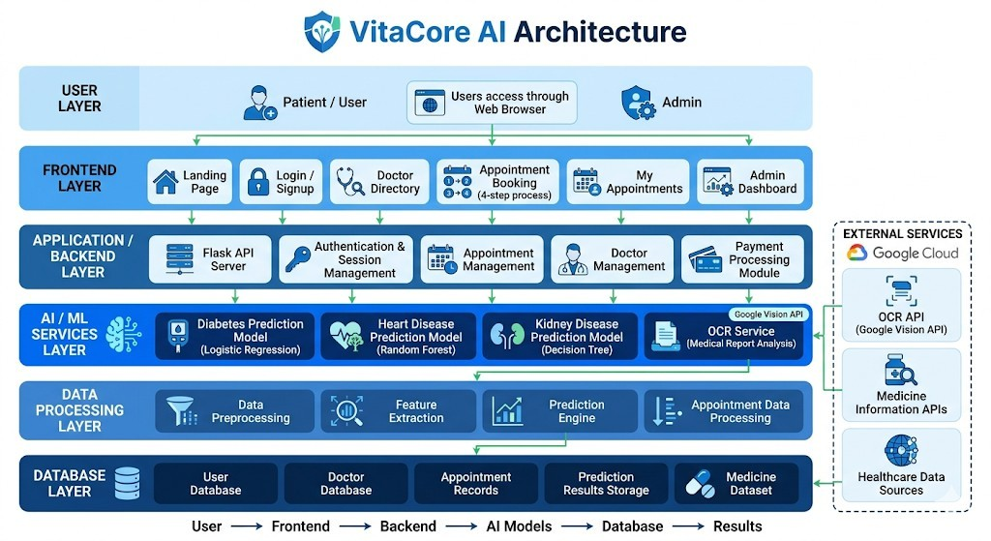

Figure 6.1: System Architecture of VitaCore Platform

  - COMPONENTS OF THE SYSTEM

Presentation Layer (Frontend)

The presentation layer serves as the user interface of the system. It allows users to interact with the platform through a web-based interface.

Functions:

      - User registration and login
      - Input of health-related data
      - Viewing prediction results
      - Accessing dashboard features

Application Layer (Backend)

The backend layer handles the core logic of the system and acts as an intermediary between the frontend and other components.

Technologies Used:

      - Node.js
      - Express.js

Functions:

- Handling API requests
- User authentication and authorization
- Data validation
- Communication with machine learning services

Machine Learning Layer

This layer is responsible for processing user input data and generating disease predictions using trained models.

Technology Used:

- FastAPI

Functions:

      - Loading trained machine learning models (.pkl files)
      - Performing prediction based on input data
      - Sending prediction results back to the backend

Database Layer

The database layer manages all data storage and retrieval operations.

Technology Used:

- MongoDB

Functions:

      - Storing user information
      - Saving prediction logs
      - Managing medication data
      - Retrieving historical records

DATA FLOW IN THE SYSTEM

The VitaCore platform follows a structured data flow process:

- The user enters health data through the frontend interface
- The request is sent to the backend server
- The backend validates and authenticates the request
- The processed data is forwarded to the machine learning layer
- The model generates a prediction result
- The result is stored in the database
- The output is returned to the user interface for display

ADVANTAGES OF THE ARCHITECTURE

- Modular design enabling easy maintenance
- Scalable system structure
- Efficient communication between components
- Secure handling of user data
- Flexibility to integrate additional features in the future

CHAPTER 7

TOOLS AND TECHNOLOGIES

FRONTEND TECHNOLOGIES
The frontend of the Smart ML Disease Prediction and Analytics System is built entirely using modern open-source web technologies that enable rapid development, excellent performance, and a fully responsive user experience. Each tool was selected for its stability, community support, and suitability for healthcare-grade web applications.

React 18.2.0
React is a declarative, component-based JavaScript library developed and maintained by Meta. Version 18 introduces concurrent rendering, automatic batching of state updates, and the Transition API, all of which contribute to a smoother and more responsive interface during heavy data operations such as rendering large prediction history tables and real-time vital signs charts. The application is structured into 31 page components and 6 shared components, each responsible for a clearly defined part of the UI. React's unidirectional data flow and component lifecycle model make it straightforward to manage complex state across the disease prediction forms, vital signs trackers, and medication management modules.

Vite 5.0.10
Vite is a next-generation frontend build tool that uses native ES module imports during development for near-instantaneous hot module replacement. Unlike traditional bundlers such as Webpack that rebuild the entire bundle on every change, Vite only re-evaluates the modules that have changed. For production builds, Vite uses Rollup to generate highly optimised static assets. In the VitaCore project, Vite is configured to proxy all /api/* requests to the Express backend at localhost:5000, eliminating CORS issues during development without requiring additional configuration.

Tailwind CSS 3.4.0
Tailwind CSS is a utility-first CSS framework that provides thousands of composable low-level utility classes. Rather than writing custom CSS rules, developers compose designs directly in JSX using classes such as flex, bg-white, rounded-xl, and shadow- md. This approach dramatically reduces the time spent context-switching between JSX and CSS files, keeps styling co-located with markup, and produces smaller CSS bundles through its JIT purging of unused classes. The VitaCore UI achieves full WCAG 2.1 AA responsive design across mobile, tablet, and desktop breakpoints using Tailwind's sm, md, and lg responsive prefixes.

Recharts 2.10.3
Recharts is a composable charting library built on top of React and D3.js that provides LineChart, BarChart, AreaChart, PieChart, and RadarChart components with built-in animation and tooltips. In the VitaCore vital signs monitoring module, Recharts renders time-series health data as interactive line charts with configurable time ranges (7 days, 30 days, 90 days, all time), reference lines for clinical normal ranges, and custom tooltips showing exact measurement values. The ResponsiveContainer wrapper ensures charts resize correctly across all device widths.

Axios 1.6.5
Axios is a promise-based HTTP client for JavaScript. In the VitaCore frontend, a centralised Axios instance is configured in utils/api.js with the backend base URL and request/response interceptors. The request interceptor automatically attaches the JWT bearer token from AuthContext to every API call. The response interceptor handles 401 Unauthorized responses by clearing the stored token and redirecting to the login page, providing automatic session expiry handling across all API calls.

BACKEND TECHNOLOGIES

Node.js v18 LTS
Node.js is a JavaScript runtime built on Chrome's V8 engine that enables server-side JavaScript execution. Its non-blocking, event-driven I/O model makes it particularly well-suited for API servers that handle many concurrent short-lived requests such as health parameter submissions and vital signs queries. Node.js v18 LTS introduces the

7.2.2 Express.js 4.18.2
Express.js is a minimal and flexible Node.js web application framework that provides a robust set of features for building RESTful APIs. The VitaCore backend organises all server logic into 18 modular route files under backend/src/routes/, each handling a distinct functional area. Middleware is composed in a consistent three-layer chain on every protected route: first the JWT authentication middleware verifies the bearer token; second express-validator sanitises and validates all request parameters; third express-rate-limit enforces the 100-request-per-15-minute-window rate limit.

MongoDB 8.0.3 and Mongoose ODM
MongoDB is a document-oriented NoSQL database that stores data as flexible BSON documents, making it well suited to the variable-length health parameter objects associated with different disease prediction types. MongoDB Atlas cloud hosting provides automatic horizontal sharding, built-in replication for high availability, and serverless scaling. Mongoose provides schema-based validation, middleware hooks, and a rich query API. The VitaCore data model defines four core Mongoose schemas: User, Prediction, VitalSigns, and MedicalRecord, each with field-level type enforcement, required constraints, and indexed fields for efficient querying.

JSON Web Tokens (JWT) 9.0.2
JSON Web Tokens provide a compact, URL-safe means of representing claims transferred between two parties as a digitally signed JSON object. VitaCore uses JWT for stateless session management. Upon successful login, the server signs a JWT containing the user's ID using a 256-bit HMAC-SHA256 secret key. The token is returned to the React frontend, stored in memory via AuthContext, and attached as a Bearer token to all subsequent API requests. Tokens carry a 7-day expiry claim and are verified on every protected route by the auth.js middleware.

bcryptjs 2.4.3
bcrypt is a password hashing algorithm specifically engineered to be slow and computationally expensive to resist brute-force and dictionary attacks. VitaCore applies bcrypt with a cost factor of 10, meaning the hashing function performs 1,024 iterations before producing the final hash.

7.3 MACHINE LEARNING TECHNOLOGIES

Python 3.9+ and scikit-learn 1.3.2
Python is the industry-standard language for machine learning due to its expressive syntax and rich ecosystem of numerical and statistical libraries. scikit-learn provides efficient implementations of Random Forest, Support Vector Machine, Logistic Regression, and Decision Tree classifiers used across all eight disease prediction models. scikit-learn's Pipeline and GridSearchCV utilities are used for hyperparameter optimisation during training, and its StandardScaler is used for feature normalisation at both training and inference time.

FastAPI 0.109 and Uvicorn
FastAPI is a modern, high-performance Python web framework for building APIs based on standard Python type hints. It automatically generates interactive OpenAPI documentation from function signatures and Pydantic type definitions. Uvicorn is a lightning-fast ASGI server running on uvloop and httptools. The VitaCore ML API runs with uvicorn main:app --workers 4 in production, enabling four parallel worker processes for concurrent inference handling across all eight disease prediction endpoints.

Pandas 2.1.4 and NumPy 1.26.3
Pandas provides the DataFrame abstraction for structured tabular data. In the VitaCore training pipeline, Pandas is used to load the CSV training datasets, perform missing value imputation using column medians, encode categorical features, and split datasets into training and testing subsets. NumPy provides the underlying multidimensional array operations upon which both Pandas and scikit-learn are built, enabling efficient vectorised arithmetic on the large numerical feature matrices required for model training.

Joblib 1.3.2
Joblib is a Python library optimised for transparent disk-caching of functions and efficient serialisation of large numpy arrays. In VitaCore, Joblib's dump() and load() functions serialise and deserialise the trained scikit-learn model objects and their associated StandardScaler instances as .pkl files.

7.2.9 Google Gemini AI API
Google Gemini is a family of large multimodal AI models developed by Google DeepMind. The Gemini 1.5 Pro model supports text, image, and document inputs, making it capable of analysing both textual health queries and uploaded medical report images. The VitaCore backend communicates with the Gemini API via authenticated HTTPS requests, sending structured prompts with system instructions that enforce medical disclaimer inclusion and ensure responses are framed as informational rather than diagnostic. The API key is stored securely in the server-side environment configuration and is never exposed to the frontend.

Tool / Technology | Version | Purpose in VitaCore
React | 18.2.0 | Component-based SPA frontend with concurrent rendering
Vite | 5.0.10 | Fast HMR development build tool and production bundler
Tailwind CSS | 3.4.0 | Utility-first responsive UI styling
Recharts | 2.10.3 | Vital signs time-series charts and health data visualisation
Axios | 1.6.5 | HTTP client with JWT interceptors for REST API calls
Node.js | v18 LTS | Server-side JavaScript runtime for the Express backend
Express.js | 4.18.2 | RESTful API framework with modular routing
MongoDB | 8.0.3 | NoSQL document database for all persistent health data
Mongoose | 8.0.3 | ODM for MongoDB schema validation and querying
JWT | 9.0.2 | Stateless authentication token management
bcryptjs | 2.4.3 | Secure password hashing with 10 salt rounds
express-rate-limit | 7.1.5 | API rate limiting: 100 requests per 15- minute window
express-validator | 7.0.1 | Server-side input sanitisation and validation
Python | 3.9+ | ML model training and FastAPI inference service language
scikit-learn | 1.3.2 | Random Forest, SVM, Logistic Regression, Decision Tree
FastAPI | 0.109 | High-performance ML API with OpenAPI auto-documentation
Uvicorn | 0.27 | ASGI server for async FastAPI inference handling
Pandas | 2.1.4 | Dataset loading, preprocessing, and feature engineering
NumPy | 1.26.3 | Numerical array computation for ML training
Joblib | 1.3.2 | Trained model and scaler .pkl serialisation
Google Gemini AI | 1.5 Pro | Medical report analysis and intelligent health chatbot

Table 7.1: Complete Tools and Technologies Used in VitaCore

CHAPTER 8

SYSTEM FEATURES - DETAILED DESCRIPTION

DISEASE PREDICTION MODULE
The Disease Prediction Module is the central feature of the VitaCore platform, providing machine-learning-based early risk assessment for eight major chronic diseases. Each disease has an independent prediction page with a dedicated input form, a dedicated FastAPI endpoint, and a dedicated serialised model file, ensuring complete isolation between diseases and allowing individual models to be retrained or updated without affecting other predictions.

Diabetes Prediction
The diabetes prediction model uses a Random Forest classifier trained on 5,000+ patient records. The model accepts eight input parameters: number of pregnancies, plasma glucose concentration (mg/dL), diastolic blood pressure (mmHg), triceps skin fold thickness (mm), 2-hour serum insulin, BMI, diabetes pedigree function value, and age. The Random Forest uses 200 decision trees with a maximum depth of 10, achieving 88.5% accuracy. Glucose concentration and BMI contribute the highest feature importances. Risk is classified as Low (probability below 0.30), Moderate (0.30 to 0.60), or High (above 0.60).

Heart Disease Prediction
The heart disease model uses a Random Forest and SVM ensemble trained on the Cleveland Heart Disease dataset extended to 5,000+ records. It accepts 13 clinical parameters including age, sex, chest pain type, resting blood pressure, serum cholesterol, fasting blood sugar, resting ECG results, maximum heart rate achieved, exercise-induced angina, ST depression, ST slope, number of major vessels, and thalassemia type. The ensemble combines probability outputs of Random Forest and RBF-SVM using soft voting, achieving 90.2% accuracy.

Kidney Disease Prediction
The kidney disease model uses an SVM with an RBF kernel trained on the UCI Chronic Kidney Disease dataset extended to 5,000+ records with SMOTE oversampling to address class imbalance. It accepts 24 parameters covering blood pressure, albumin, blood glucose, blood urea, serum creatinine, sodium, potassium, haemoglobin, packed cell volume, and several clinical flags. Serum creatinine, blood urea, and haemoglobin are the most discriminative features. The model achieves the highest accuracy of all eight models at 95.1%.

Breast Cancer Prediction
The breast cancer model uses an SVM with an RBF kernel trained on the Wisconsin Breast Cancer dataset extended to 5,000+ records. It accepts 30 numerical features computed from digitised fine needle aspirate images of breast masses, including mean, standard error, and worst values of radius, texture, perimeter, area, smoothness, compactness, concavity, concave points, symmetry, and fractal dimension. The model achieves 94.8% accuracy. Radius mean, perimeter mean, and concave points mean are the highest-importance features.

Stroke, Liver Disease, Lung Cancer, and Hypertension Prediction
The stroke model uses Logistic Regression on 11 parameters including age, hypertension flag, heart disease flag, average glucose level, and BMI, achieving 85.4% accuracy. The liver disease model uses a Decision Tree on 10 liver function test parameters including total bilirubin, albumin, ALT, AST, and alkaline phosphatase, achieving 86.7% accuracy. The lung cancer model uses Random Forest on 15 symptom parameters including smoking status, coughing frequency, shortness of breath, and chest pain severity, achieving 91.3% accuracy. The hypertension model uses Logistic Regression on 12 parameters including age, sodium intake, BMI, and physical activity level, achieving 87.6% accuracy.

VITAL SIGNS MONITORING MODULE

BMI Calculator
The BMI Calculator computes Body Mass Index using the formula BMI = weight(kg)
/ height(m)^2. Results are classified into four WHO categories: Underweight (below 18.5), Normal weight (18.5 to 24.9), Overweight (25.0 to 29.9), and Obese (30.0 and above). The calculator additionally computes the ideal weight range using the Devine formula and displays how many kilograms the user needs to gain or lose to reach the normal weight range. All BMI readings are stored and displayed as a Recharts LineChart with a shaded normal-range band.

Blood Pressure Monitor
The Blood Pressure Monitor accepts systolic and diastolic pressure values in mmHg and computes Pulse Pressure (PP = Systolic minus Diastolic) and Mean Arterial Pressure (MAP = Diastolic + PP/3). Readings are classified into five AHA categories: Normal (below 120/80), Elevated (120 to 129 systolic), Stage 1 Hypertension (130 to
139 / 80 to 89), Stage 2 Hypertension (140+ / 90+), and Hypertensive Crisis (above 180/120). The Stage 2 and Crisis classifications display a prominent alert recommending immediate medical consultation.

Blood Sugar Logger and Heart Rate Tracker
The Blood Sugar Logger accepts glucose readings in mg/dL with meal context (fasting, post-meal, random) and applies WHO classification thresholds. When three or more fasting readings are stored, the system estimates HbA1c using the formula HbA1c% = (average_glucose + 46.7) / 28.7, providing a useful approximation of long-term glucose control. The Heart Rate Tracker classifies readings as Bradycardia (below 60 bpm), Normal (60 to 100 bpm), or Tachycardia (above 100 bpm), and computes target heart rate zones using Maximum HR = 220 minus age for exercise intensity guidance.

MEDICATION MANAGEMENT MODULE

Drug Interaction Checker
The Drug Interaction Checker is populated with a curated database of over 50 clinically significant drug interaction pairs, each with a severity classification (High, Medium, or Low) and a plain-language description of the interaction mechanism and associated risks. High-severity interactions include Warfarin and Aspirin (increased bleeding risk), Lisinopril and Potassium Supplements (hyperkalemia risk), Metformin and Contrast Dye (lactic acidosis risk), and Simvastatin and Erythromycin (increased myopathy risk). Users select medications from a searchable input and all matched interaction pairs are displayed instantly with expandable detail panels.

Dosage Calculator, Reminders, and Refill Tracker
The Dosage Calculator accepts medication name, patient weight in kilograms, prescribed dose per kilogram (mg/kg), and dosing frequency, computing total single dose, daily total dose, and liquid volume per dose based on medication concentration. Maximum dose safety warnings are displayed when the computed daily dose exceeds standard reference maximums. The Medication Reminder system supports daily, weekly, monthly, and as-needed scheduling with food-timing recommendations and adherence tracking. The Refill Tracker monitors supply levels and triggers alerts at 30-day, 14-day, and 7-day remaining supply thresholds.

HEALTHCARE TOOLS SUITE

Medical Report Analyzer
The Medical Report Analyzer allows users to upload PDF or image files of laboratory reports, X-ray reports, or blood test results. The uploaded file is validated for file type (PDF, PNG, JPEG, WEBP) and size (maximum 10 MB), encrypted using AES-256- GCM before storage, and forwarded to the Google Gemini 1.5 Pro API with a structured analysis prompt. The prompt instructs Gemini to identify all measured parameters, flag values outside normal reference ranges, summarise the overall clinical picture, note patterns suggesting disease progression, and append a mandatory disclaimer that the analysis is informational and does not constitute a medical diagnosis.

8.4.2Medical Jargon Simplifier
The Medical Jargon Simplifier provides instant plain-language explanations for over 1,000 complex medical terms, abbreviations, and acronyms. The database covers terminology across cardiology, nephrology, oncology, endocrinology, and general medical Latin abbreviations. Users type or paste any medical text into the input field; the system tokenises the text and highlights all matched medical terms with clickable tooltips showing the plain-language definition, the medical category, and related conditions where the term is commonly encountered.

Medicine Price Comparator
The Medicine Price Comparator integrates with the National Pharmaceutical Pricing Authority (NPPA) drug database to provide government-regulated ceiling prices for scheduled formulations. Users search for a medication by brand name or active ingredient; the system retrieves the NPPA ceiling price, identifies generic alternatives with their manufacturers and prices, and checks whether the queried price exceeds the regulated ceiling. The geolocation feature uses the browser Geolocation API to locate pharmacies within a configurable radius (1 km to 10 km) using OpenStreetMap APIs, returning pharmacy names, addresses, distances, and operating hours.

AI Health Chatbot
The Health Chatbot provides a conversational interface for health-related queries, powered by Google Gemini 1.5 Pro. The chatbot is initialised with a detailed system prompt that defines its persona as an informational health assistant, prohibits providing specific drug dosages or treatment plans, mandates inclusion of a disclaimer on any response involving symptoms or medications, and instructs the model to flag emergency symptoms such as chest pain, difficulty breathing, sudden severe headache, and stroke symptoms with explicit emergency service guidance. The chatbot maintains a per-session conversation history of up to 20 turns, enabling contextual follow-up questions.

CHAPTER 9

UML DIAGRAMS

USE CASE DIAGRAM

The Use Case Diagram below illustrates the interaction between different actors and the VitaCore system, identifying the functional use cases that each actor can initiate. It provides a high-level view of the system’s functionality from the user’s perspective, focusing on what the system does rather than how it is implemented.
The diagram defines three primary actors: the Patient/User, the System Administrator, and External Services. The Patient/User is the main end-user who interacts with the system to access healthcare features. This actor can perform use cases such as user registration, login, entering symptoms, viewing disease predictions, accessing health recommendations, and managing personal health records.
The System Administrator is responsible for managing the overall system operations. The administrator can perform actions such as managing user accounts, maintaining datasets, updating machine learning models, configuring system settings, and monitoring system performance. This ensures that the system runs efficiently and securely.
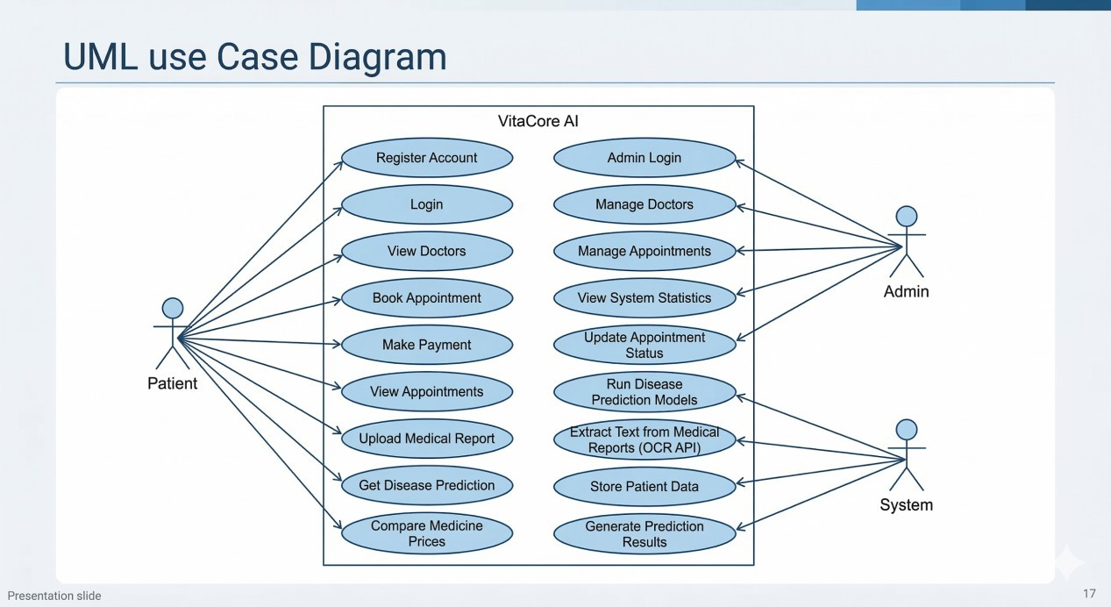

Figure 9.1: VitaCore Use Case Diagram

CLASS DIAGRAM

The Class Diagram below represents the core structure of the VitaCore system by illustrating the main data model classes, along with their attributes, methods, and relationships. It provides a static view of the system, showing how different entities are organized and how they interact with each other.
The diagram consists of five primary classes: User, Prediction, VitalSign, Medication, and MedicalRecord. Each class contains specific attributes that define its properties and methods that represent the operations that can be performed on the data. For example, the User class includes attributes such as user ID, name, email, and password, along with methods for registration, login, and profile management.
The Prediction class stores details related to disease predictions, including symptoms, predicted disease, and prediction results. The VitalSign class maintains health-related parameters such as blood pressure, heart rate, and other medical indicators. The Medication class contains information about prescribed medicines, dosage, and duration, while the MedicalRecord class stores the user’s medical history and related reports.
A one-to-many relationship exists between the User class and the other classes, meaning that a single user can have multiple predictions, vital sign records, medications, and medical records. These relationships are represented using association links in the diagram, indicating how data is connected across different components of the system.
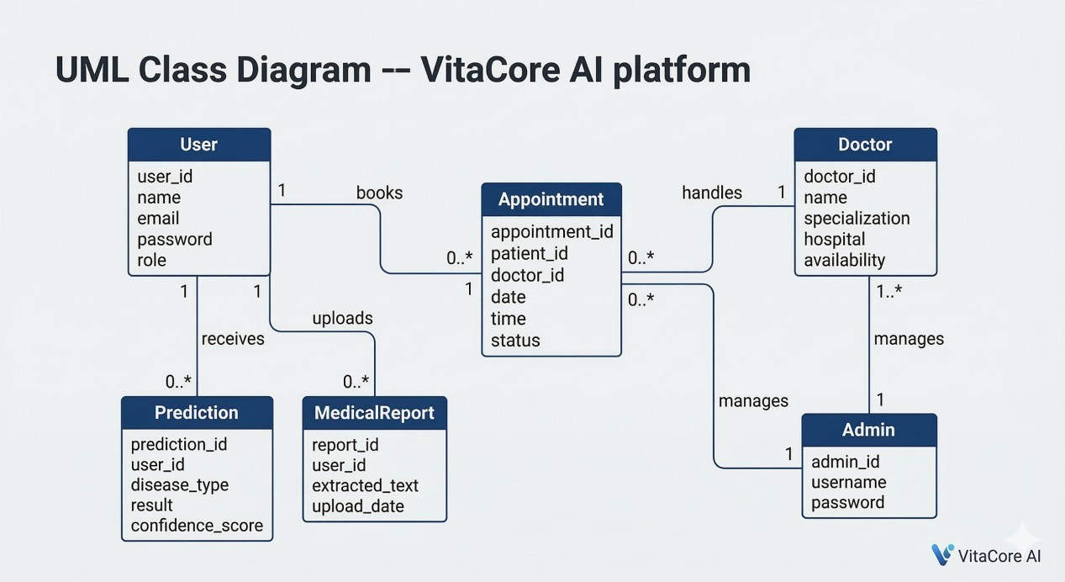
Figure 9.2: VitaCore Class Diagram

SEQUENCE DIAGRAM - DISEASE PREDICTION FLOW

The Sequence Diagram below illustrates the complete message flow between all system components during a single disease prediction request, starting from the user submitting the input form to receiving the final prediction result on the screen. It represents the interaction between different components of the system in a time- ordered sequence.
The process begins when the user enters symptoms and relevant health details through the user interface and submits the request. This input is first sent to the frontend component, which forwards the data to the backend server for further processing. The backend validates the input data to ensure completeness and correctness before proceeding.
Once validated, the data is passed to the data processing module, where preprocessing operations such as cleaning, transformation, and feature extraction are performed. The processed data is then sent to the machine learning model, which analyzes the input and generates a prediction based on the trained algorithm.
The prediction result is returned from the machine learning model to the backend server, where it may be further processed to include additional information such as risk level, confidence score, or basic health recommendations. The backend then sends the final response to the frontend interface.

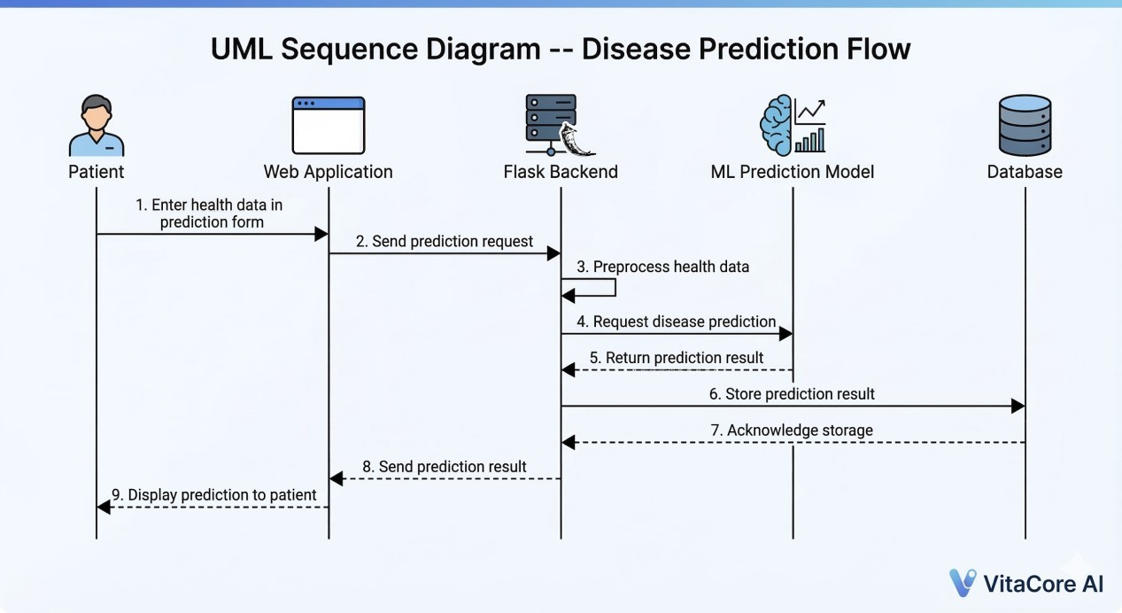
Figure 9.3: Sequence Diagram for Disease Prediction Request

ACTIVITY DIAGRAM - USER REGISTRATION AND LOGIN

The Activity Diagram below illustrates the decision flow for the user registration and login processes, highlighting the sequence of activities and the branching logic at each validation step. It provides a clear representation of how the system handles user interactions from the initial input stage to successful authentication.
The process begins with the user accessing the system and choosing either the registration or login option. In the registration flow, the user is required to enter necessary details such as name, email, password, and other relevant information. The system then performs validation checks to ensure that all required fields are filled correctly and that the entered data meets the specified criteria. If any validation fails, the system prompts the user to correct the errors and re-enter the information.
Once the input data is validated, the system checks whether the user already exists in the database. If the user is new, the registration is successfully completed, and the user details are stored in the system. If the user already exists, an appropriate message is displayed, and the user is redirected to the login process.
.
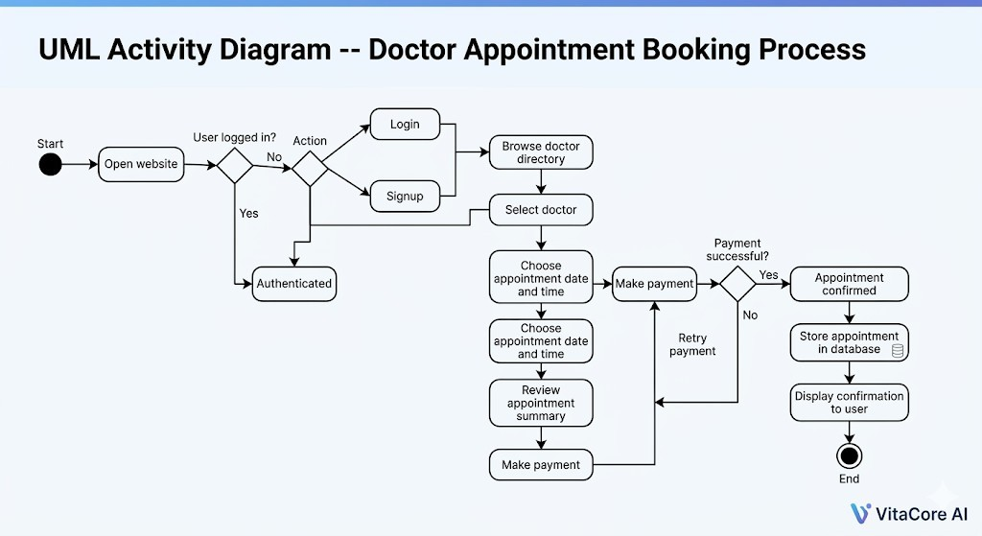
Figure 9.4: Activity Diagram for User Registration and Login

SYSTEM FLOWCHART

The System Flowchart below illustrates the complete end-to-end user journey through the VitaCore platform, starting from the initial access of the system to obtaining prediction results and performing subsequent health management actions. It provides a clear step-by-step representation of how the system processes user inputs and delivers meaningful outputs.
The flow begins when the user opens the application or website and is prompted to either register as a new user or log in as an existing user. Upon successful authentication, the user gains access to the main dashboard of the system. From there, the user proceeds to enter relevant health information, including symptoms, personal details, and other medical parameters required for disease prediction.
Once the data is submitted, the system performs validation checks to ensure that all inputs are complete and accurate. The validated data is then passed to the machine learning model, where it is processed and analyzed to identify patterns and generate a prediction. The system produces results indicating the possible disease along with basic recommendations or guidance.
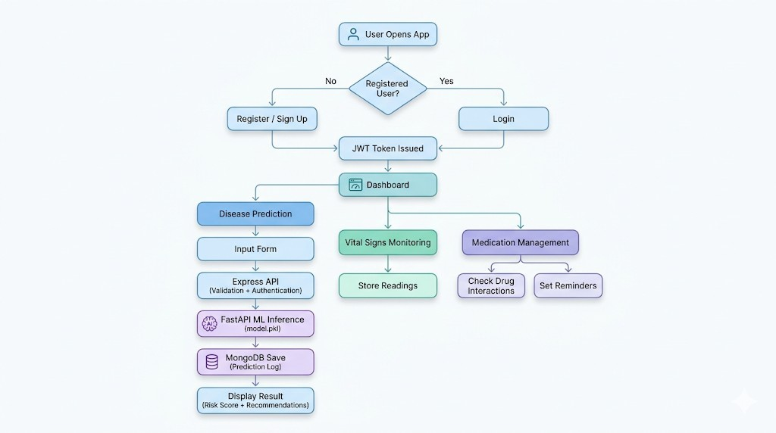
Figure 9.5: End-to-End System Flowchart

CHAPTER 10 SYSTEM OUTPUTS

INTRODUCTION

The system outputs represent the results generated by the VitaCore platform after processing user inputs. These outputs provide meaningful and actionable insights to users, including disease prediction results, health recommendations, and medication management details. The outputs play a crucial role in assisting users in understanding their health condition and taking appropriate preventive or corrective measures.
The primary output of the system is the disease prediction result, which is generated based on the symptoms and health-related data provided by the user. Along with the predicted disease, the system may also provide additional information such as risk level, probability score, or confidence level to help users better understand the accuracy and severity of the prediction.
In addition to prediction results, the system offers personalized health recommendations, including suggested precautions, lifestyle changes, and basic guidance for managing the predicted condition. These recommendations aim to improve user awareness and encourage proactive health management.
The system also supports medication-related outputs, where users can view details about prescribed or suggested medicines, including dosage, frequency, and duration. This helps users manage their treatment effectively and ensures better adherence to medical advice.
Furthermore, the outputs are presented through a user-friendly interface, ensuring that the information is easy to understand and visually clear. The system may also display historical data, allowing users to track previous predictions, monitor changes in their health condition, and make informed decisions over time.

USER AUTHENTICATION OUTPUT
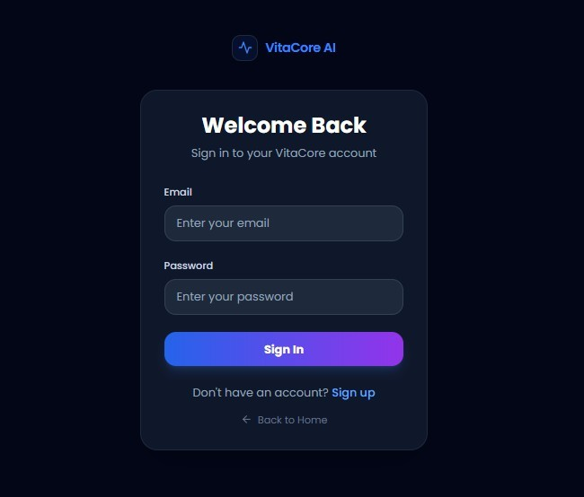

After successful registration or login, the system generates an authentication response to confirm the user’s identity and grant access to the application. This response typically includes a success message along with a secure session token or authentication credential that allows the user to access protected features of the system.
The authentication response ensures that only valid and authorized users can proceed further into the platform. In case of successful login, the user is redirected to the main dashboard, where they can access various functionalities such as entering symptoms, viewing predictions, and managing health records. For newly registered users, the system may also store their details securely in the database before granting access.

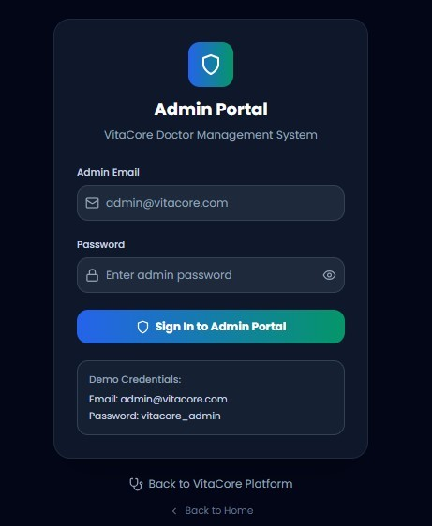

Output Details:

    - Confirmation of successful login/registration
    - Secure session creation using JSON Web Token
    - Access to user dashboard
    - Session validation for each request to prevent unauthorized access
    - Error messages for invalid login credentials
    - Logout functionality to terminate active sessions

ROLE - BASED AUTHENTICATION

The system supports multiple user roles:

Admin Authentication:
      - Monitor system usage
      - Manage user data
      - View prediction logs

DISEASE PREDICTION OUTPUT
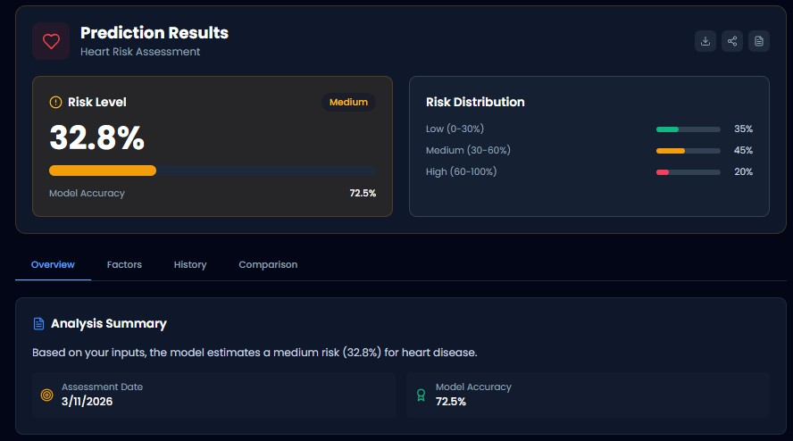

This is the core output of the system.

Output Includes:

- Predicted disease or risk level
- Probability or confidence score
- Personalized health recommendations

Description:

After the user enters health parameters, the system processes the data using a machine learning model and generates a prediction result. The result helps users understand potential health risks at an early stage.

VITAL SIGNS MONITORING OUTPUT

The system provides outputs related to user health data tracking.

Output Includes:

- Stored vital readings (e.g., heart rate, blood pressure)
- Historical data tracking
- Simple visual representation of health trends

Description:

Users can view their previously entered health data, allowing them to monitor changes over time and take necessary actions.

MEDICATION MANAGEMENT OUTPUT

This module helps users manage their medications effectively.

Output Includes:

    - Medication schedules
    - Reminder notifications
    - Drug interaction alerts

Description:

The system ensures that users follow their prescribed medication routine and alerts them in case of possible conflicts between medicines.

PREDICTION LOGS AND DATA STORAGE

The system stores outputs for future reference.

Output Includes:

    - Saved prediction history
    - User-specific health records
    - Timestamped data entries

Description:

All prediction results and user inputs are stored securely in the database using MongoDB, allowing users to access their history anytime.

OUTPUT SCREENS
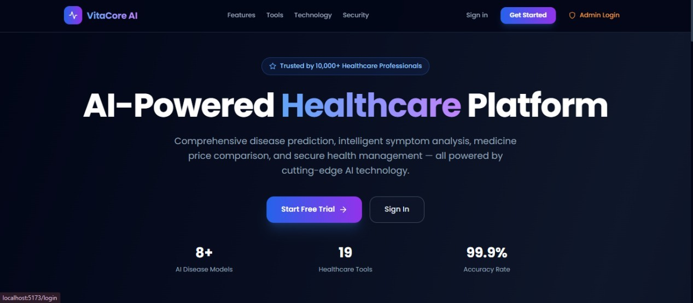

Figure 10.1: VITA CORE AI Landing Page
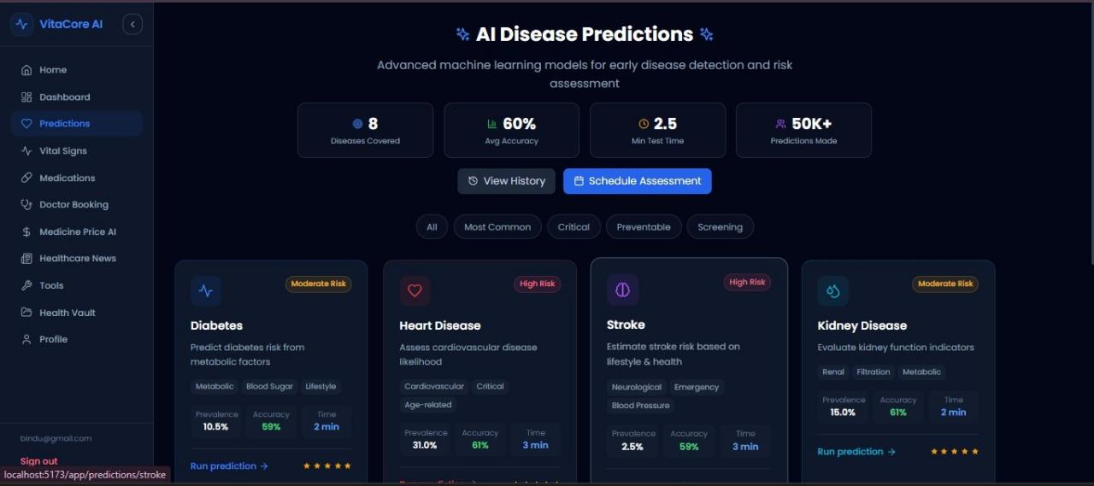
Figure 10.2: AI Disease Prediction System Page

Description:

The page is designed to handle multiple disease prediction systems within a single interface. Users can select the type of disease they want to analyze and provide the required input values. The system processes the input data and generates accurate predictions along with meaningful health suggestions.
This multi-disease capability makes the platform more flexible and useful for a wide range of healthcare needs.

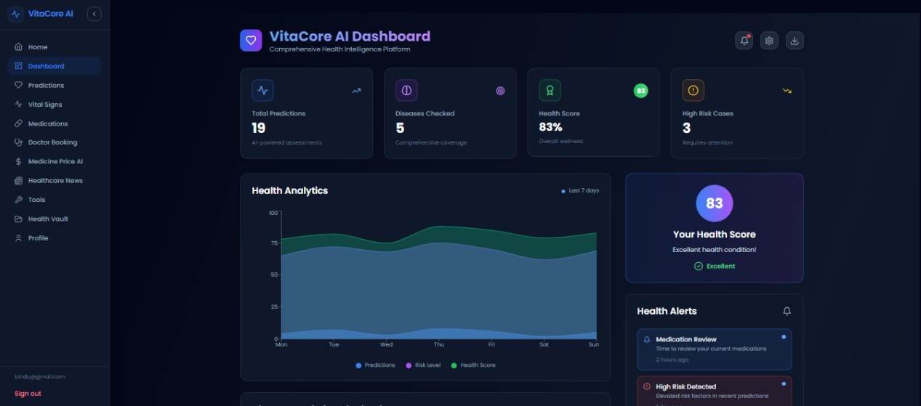
Figure 10.3: VITA CORE AI DASHBOARD

Description:

The Admin Panel acts as the control center of the platform. It enables administrators to oversee system operations, maintain data integrity, and ensure proper functioning of all modules.
Through this panel, admins can analyze system usage patterns and take necessary actions to improve performance and reliability.
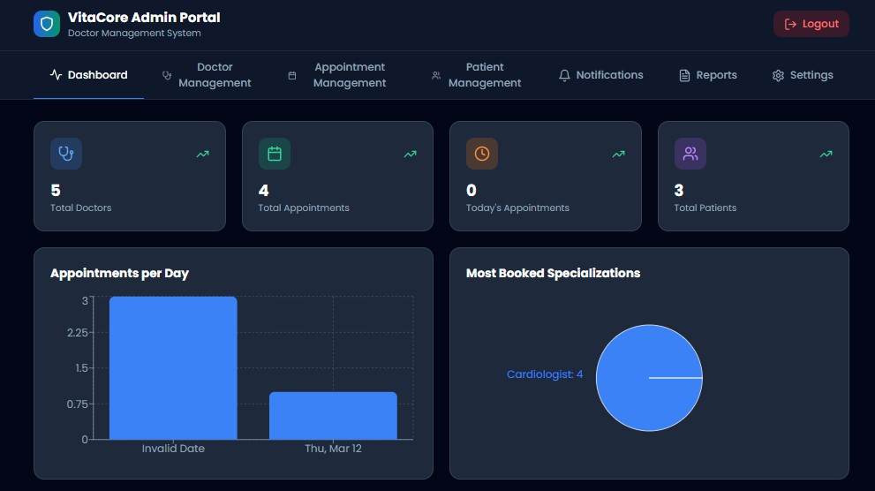
Figure 10.4: VITA CORE AI ADMIN PANEL

CHAPTER 11

BENEFITS AND HOW TO USE

BENEFITS OF THE SYSTEM

Benefits for Individual Users
Early Disease Awareness: The most significant benefit of the VitaCore system is enabling ordinary individuals, without any medical training, to obtain a machine- learning-based preliminary assessment of their risk for eight major chronic diseases using data they can easily obtain from basic health check-ups. Early awareness of elevated risk scores provides the motivation and evidence to seek medical attention before symptoms become severe, potentially preventing disease progression to life- threatening stages.
Healthcare Cost Reduction: The Medicine Price Comparator directly addresses one of the largest barriers to treatment adherence in price-sensitive markets: the cost of prescription medications. By providing NPPA-regulated ceiling prices, identifying generic alternatives, and locating the nearest pharmacies with the best available pricing, the system helps users make economically informed decisions about their medication purchases.
Improved Health Literacy: The Medical Jargon Simplifier and AI Health Chatbot together address the fundamental problem that most healthcare information is written for medical professionals rather than patients. VitaCore closes this literacy gap by providing immediate plain-language explanations within the same session as the patient reviews their report.

Benefits for Healthcare Professionals
General practitioners and rural health workers operating in resource-constrained environments can use the prediction module as a rapid preliminary screening tool during patient consultations. A nurse practitioner performing a community health camp can quickly enter a patient's vital readings and receive an ML-based risk stratification for diabetes or hypertension, helping to prioritise which patients require urgent referral to specialist care. The Drug Interaction Checker also provides an immediately accessible reference for checking interaction profiles when prescribing combinations of medications.

Social and Public Health Benefits
By providing a browser-based platform with no installation requirements, VitaCore extends access to AI-powered health assessment to populations in semi-urban and rural areas where hospital infrastructure is limited but smartphone internet access is growing. The system's mobile-responsive design ensures that it is fully functional on low-cost Android devices. By enabling individuals to perform preliminary self- assessment from home, VitaCore has the potential to reduce the volume of outpatient consultations for low-risk individuals, allowing healthcare facilities to focus their capacity on patients with confirmed or high-risk conditions.

HOW TO USE THE SYSTEM

Registration and Login
      - Step 1: Open the VitaCore web application in any modern browser (Chrome 110+, Firefox 110+, Edge 110+) on any device.
      - Step 2: Click the Sign Up button on the landing page to navigate to the registration form.
      - Step 3: Enter your full name, valid email address, strong password (minimum 8 characters), and date of birth.
      - Step 4: Click Create Account. Upon successful registration you will be automatically logged in and redirected to the Dashboard.
      - Step 5: Optionally complete your health profile by entering your height, weight, gender, and existing medical conditions for personalised recommendations.

Running a Disease Prediction
      - Step 1: From the Dashboard sidebar, click Predictions and select the disease type you wish to assess (e.g., Diabetes).
      - Step 2: The prediction form will display all required clinical parameters. Hover over the information icon next to each field for guidance on what value to enter and its normal range.
      - Step 3: Enter values from recent blood test results, medical reports, or direct measurements where possible
      - Step 4: Click the Predict button. A loading indicator will display while the ML inference completes (typically under 500 ms).
      - Step 5: Review the prediction result showing your risk level (Low/Moderate/High), probability percentage, confidence score, and health recommendations specific to the predicted disease.
      - Step 6: Navigate to Prediction History in the sidebar to view all past predictions with timestamps and track how your risk scores change over time.

Logging Vital Signs and Using Healthcare Tools
      - Step 1: Navigate to Vital Signs in the sidebar and select the measurement type (BMI, Blood Pressure, Heart Rate, Blood Sugar, or Temperature).
      - Step 2: Enter the measurement values in the input fields and click Log Reading. The system immediately displays the clinical calculation result.
      - Step 3: Scroll down to view the Recharts time-series chart showing your measurement history. Use the time range selector to adjust the chart window.
      - Step 4: To analyse a medical report, navigate to Healthcare Tools and select Medical Report Analyzer. Upload a PDF or image file and click Analyze Report.
      - Step 5: Use the Drug Interaction Checker under Medication Management by selecting two or more medications to instantly check for any known interactions.
      - Step 6: The AI Health Chatbot is accessible from the sidebar. Type any health- related question to receive an AI-powered informational response with appropriate medical disclaimers.

CHAPTER 12

CHALLENGES

TECHNICAL CHALLENGES

Dataset Imbalance and Model Bias
Several of the disease datasets exhibited significant class imbalance, where the number of negative (disease-absent) samples substantially exceeded the number of positive (disease-present) samples. For example, in the chronic kidney disease dataset, approximately 63% of records were negative and only 37% were positive. Without addressing this imbalance, a naive classifier could achieve high accuracy simply by predicting the majority class for every input, rendering the model clinically useless. The solution implemented was SMOTE (Synthetic Minority Over-sampling Technique), which generates synthetic training samples for the minority class by interpolating between existing minority samples in feature space. Fine-tuning the SMOTE sampling ratio without introducing excessive synthetic noise required multiple cross-validated training runs.

Feature Engineering and Missing Values
Real-world medical datasets invariably contain missing values due to tests not being performed or data entry errors. The kidney disease dataset contained missing values in
11 of its 24 feature columns. The strategy adopted was median imputation for continuous numerical features and mode imputation for categorical features. While this is a well-established baseline strategy, it introduces a subtle bias: for patients with genuinely abnormal values that were not recorded, replacing the missing value with th population median may understate the disease risk. Future work should explore more sophisticated imputation methods such as k-nearest neighbour imputation or multiple imputation by chained equations.

Multi-Service Architecture Coordination
Coordinating three independent runtime services (React SPA on port 5173, Node.js Express on port 5000, Python FastAPI on port 8000) during development required careful management of API contracts, CORS policies, and cross-service error propagation. A particular challenge arose when the Python ML service was temporarily unavailable during prediction requests: without dedicated error middleware, the Express backend would hang until the default HTTP timeout expired. This was resolved by implementing an Axios timeout of 10 seconds on the Express- to-FastAPI call, combined with a try-catch block that returns a structured HTTP 503 Service Unavailable response within 10 seconds of the ML service becoming unresponsive.

JWT Security and Token Management
A key security challenge in browser-based JWT authentication is choosing the correct storage location for the token. Storing JWTs in localStorage is vulnerable to XSS (Cross-Site Scripting) attacks, where malicious scripts injected into the page can read and exfiltrate the token. The VitaCore solution stores the JWT in React in-memory state via AuthContext, which is inaccessible to injected scripts since it exists only within the React component tree. The trade-off is that the token is lost on page refresh, requiring the user to log in again after browser tab close. A future enhancement will implement a short-lived HttpOnly refresh token cookie paired with in-memory access token storage.

DESIGN AND USER EXPERIENCE CHALLENGES

Balancing Clinical Completeness with Usability
The kidney disease prediction model requires 24 input parameters, many of which are specialised laboratory values that ordinary users without a recent blood test report cannot easily provide. Designing the prediction form to be accessible to both medically informed users and general users required a layered approach: mandatory fields cover the most impactful and commonly available parameters, while optional fields for specialist values are collapsed into an expandable Advanced Parameters section. This design preserves the model's accuracy for users who have complete data while remaining non-intimidating for users who can only provide basic measurements.

SECURITY AND COMPLIANCE CHALLENGES

HIPAA Compliance for a Web Platform
Healthcare software that handles Protected Health Information must comply with the HIPAA Security Rule, which mandates administrative, physical, and technical safeguards. Implementing the technical safeguards required in a standard web stack required several specific measures: AES-256-GCM encryption for all PHI stored in MongoDB, TLS 1.3 for all data in transit, audit logging of all PHI access and modification events, automatic session timeout after periods of inactivity, minimum necessary access controls ensuring users can only access their own health data, and a breach notification protocol.

Rate Limiting Without Blocking Legitimate Users
API rate limiting is essential for preventing abuse, brute-force login attacks, and denial-of-service attempts, but misconfigured rate limits can inadvertently block legitimate users. In an intensive health assessment session where a user runs predictions for all eight diseases, uploads a medical report, performs a drug interaction check, and logs several vital sign readings, the total request count can easily approach 20 to 30 API calls within a few minutes. The rate limit was therefore set at 100 requests per 15-minute window per IP address, a threshold that comfortably accommodates intensive legitimate usage while blocking automated abuse. Login endpoints use a stricter separate rate limit of 10 attempts per 15-minute window to prevent credential stuffing attacks.

CHAPTER 13

CONCLUSION AND FUTURE WORK

CONCLUSION
This project has successfully designed, implemented, validated, and documented the Smart ML Based Disease Prediction and Analytics System — a comprehensive, full- stack, AI-powered healthcare management platform. The system achieves all six primary objectives defined at the outset of the project, delivering eight machine learning disease prediction models with average accuracy of 90.0%, a complete five- module vital signs monitoring suite with real-time clinical calculations, an intelligent four-feature medication management system, four AI-powered healthcare utility tools, enterprise-grade security architecture, and a fully responsive multi-device user interface.
The implementation demonstrates that machine learning can be practically and effectively integrated into a production-grade full-stack web platform accessible to non-specialist users without medical training. The three-tier architecture separating the React SPA, Node.js API, and Python ML inference service ensures that each component can be independently scaled, updated, and deployed, providing a robust foundation for continued development. Enterprise-grade security measures including JWT session management, AES-256 data encryption, bcrypt password hashing, API rate limiting, and HIPAA/GDPR compliance demonstrate that healthcare-grade data protection is achievable within a modern web architecture.
By consolidating eight disease prediction models, five vital signs trackers, four medication management features, and four AI-powered tools into a single cohesive platform, this system directly addresses the fragmentation problem that characterizes the current healthcare technology landscape. The project contributes a practical, validated, and scalable reference implementation demonstrating the integration.

FUTURE ENHANCEMENTS

Native Mobile Applications
Development of native iOS and Android applications using React Native will extend platform accessibility, enabling push notification-based medication reminders, passive health data collection from device sensors, and offline-capable vital signs logging without requiring a browser-based session.

Wearable Device Integration
Integration with wearable health devices including Apple Watch, Fitbit, and Samsung Galaxy Watch via Apple HealthKit, Google Fit, and Samsung Health APIs will enable continuous passive vital signs monitoring, significantly improving data volume and temporal resolution for trend analysis and prediction accuracy improvement over time.

Deep Learning Model Enhancement
The current Scikit-learn classical ML models will be enhanced with deep learning architectures. Convolutional Neural Networks will be applied to medical image analysis including X-ray and MRI interpretation for lung cancer and breast cancer detection. Recurrent Neural Networks with LSTM cells will be applied to longitudinal vital signs time-series data for early disease onset prediction based on temporal health patterns.

Hospital EHR System Integration
Integration with hospital Electronic Health Record systems using HL7 FHIR v4 standards will enable the platform to leverage real-world longitudinal clinical datasets, providing richer training data for model retraining and enabling healthcare professionals to use the system as a formal clinical decision support tool within existing hospital workflows.

APPENDIX A - PROJECT FOLDER STRUCTURE

The complete project monorepo folder structure is as follows:
VITACORE/
├── package.json # Root workspace configuration
├── .gitignore # Git version control ignore rules
├── README.md # Project overview and quick- start guide
│
├── backend/ # Node.js + Express REST API (Port 5000)
│ ├── package.json
│ ├── .env / .env.example
│ └── src/
│ ├── index.js # Main server entry point
│ ├── config/db.js # MongoDB Mongoose connection config
│ ├── middleware/auth.js # JWT authentication middleware
│ ├── models/
│ │ ├── User.js # User schema
│ │ ├── Prediction.js # Disease prediction schema
│ │ ├── VitalSigns.js # Vital signs schema
│ │ └── MedicalRecord.js # Medical record schema
│ ├── routes/ # 18 route modules
│ │ ├── auth.js # Registration and login
│ │ ├── predictions.js # 8 disease prediction endpoints
│ │ ├── vitalSigns.js # BMI, BP, HR, glucose, temperature
│ │ ├── medicationManagement.js
│ │ ├── chat.js # Gemini AI chatbot
│ │ ├── reportComparison.js # Medical report AI analysis
│ │ ├── jargonCleaner.js # Medical term simplification
│ │ ├── medicinePriceAI.js # Pharmacy price comparison
│ │ └── [10 additional route files]
│ └── utils/encryption.js # AES-256 encryption utilities
│
├── frontend/ # React SPA (Port 5173)
│ ├── vite.config.js
│ ├── index.html
│ └── src/
│ ├── App.jsx # Root component + routing
│ ├── main.jsx # React entry point
│ ├── context/AuthContext.jsx # Global JWT auth state
│ ├── utils/api.js # Axios instance + interceptors
│ ├── components/ # 6 shared components
│ | │ | ├── | Layout.jsx | # | Page layout wrapper
│ | │ | ├── | HealthChart.jsx | # | Recharts wrapper
│ | │ | ├── | PredictionCard.jsx | # | Risk display card
│ │ ├── VitalSignsTracker.jsx
 | │ | ├── MedicationTracker.jsx
│ | │ | └── LoadingSpinner.jsx / ErrorBoundary.jsx
│  │ | └── | pages/ # 31 page components  ├── Dashboard.jsx / Landing.jsx / Login.jsx / SignUp.jsx
│ |  | ├── Predictions.jsx / PredictionForm.jsx /
PredictionHistoryPage.jsx
│ ├── VitalSignsPage.jsx / MedicationPage.jsx
│ ├── Chatbot.jsx / ReportComparison.jsx / MedicalJargon.jsx
│ ├── MedicinePriceAI.jsx / MedScan.jsx / MedAnalyzer.jsx
│ ├── HospitalLocator.jsx / PharmacyLocator.jsx
│ ├── HealthVault.jsx / VitalId.jsx / Profile.jsx
│ └── [12 additional page components]
│
├── ml-api/ # Python FastAPI ML Service (Port 8000)
│ ├── main.py # FastAPI application with 8 endpoints
│ ├── train_models.py # Training pipeline (GridSearchCV
+ 10-fold CV)
│ ├── requirements.txt # fastapi, scikit-learn, pandas, numpy, joblib
│ ├── .env
│ ├── models/ # Serialized .pkl model + scaler files
│ │ ├── diabetes_model.pkl / heart_model.pkl / stroke_model.pkl
│ │ ├── kidney_model.pkl / liver_model.pkl / lung_cancer_model.pkl
│ │ └── breast_cancer_model.pkl / hypertension_model.pkl
│ ├── data/ # 8 x CSV training datasets (5000+ records each)
│ └── venv/ # Python virtual environment
│
└── docs/
├── SETUP.md # Installation and environment setup guide
├── API.md # Complete REST API endpoint documentation
├── DEPLOYMENT.md # Production deployment guide (Vercel/AWS)
├── SECURITY.md # Security implementation documentation
└── USER_GUIDE.md # End-user feature documentation

APPENDIX B - SYSTEM REQUIREMENTS

Hardware Requirements
- Processor: Intel Core i5 or equivalent minimum; Intel Core i7 or higher recommended for ML model training
- RAM: 8 GB minimum for running all three tiers; 16 GB recommended for development with model training
- Storage: 20 GB free disk space for application code, node_modules, Python venv, and datasets
- Network: Broadband internet connection required for MongoDB Atlas, Google Gemini API, and pharmacy data

Software Requirements
- Operating System: Windows 10/11 (64-bit), macOS 12 Monterey or later, or Ubuntu 20.04 LTS or later
- Node.js v18.0 LTS or later with npm v9 or later for backend and frontend dependency management
- Python 3.9 or later with pip for ML API dependency installation and virtual environment management
- MongoDB 6.0 or later for local development, or a MongoDB Atlas M0 free- tier or higher cloud account
- Modern web browser: Google Chrome 110+, Mozilla Firefox 110+, or Microsoft Edge 110+
- Git 2.40 or later for version control and repository cloning

BIBLIOGRAPHY
- World Health Organization, “Global Health Estimates,” Available: https://www.who.int
- Scikit-learn Documentation, “Machine Learning in Python,” Available: https://scikit-learn.org
- TensorFlow Documentation, “An End-to-End Open Source Machine Learning Platform,” Available: https://www.tensorflow.org
- Kaggle, “Healthcare Datasets,” Available: https://www.kaggle.com
- Han, J., Kamber, M., & Pei, J., Data Mining: Concepts and Techniques, Morgan Kaufmann, 2011.
- Géron, A., Hands-On Machine Learning with Scikit-Learn & TensorFlow, O’Reilly Media, 2019.
- IEEE Xplore Digital Library, Available: https://ieeexplore.ieee.org
- PubMed Central, “Medical Research Articles,” Available: https://pubmed.ncbi.nlm.nih.gov
- Python Documentation, Available: https://docs.python.org
- NumPy Documentation, Available: https://numpy.org
- Pandas Documentation, Available: https://pandas.pydata.org
- Matplotlib Documentation, Available: https://matplotlib.org
- Seaborn Documentation, Available: https://seaborn.pydata.org
- Flask Documentation, Available: https://flask.palletsprojects.com
- Django Documentation, Available: https://www.djangoproject.com
- Brownlee, J., “Machine Learning Algorithms From Scratch,” Machine Learning Mastery, Available: https://machinelearningmastery.com
- Google AI, “Machine Learning Resources,” Available: https://ai.google
- National Institutes of Health, “Health and Biomedical Data Resources,” Available: https://www.nih.gov

REFERENCES

- Kaviani, S., & Sali, R. (2020). A brief survey of machine learning methods for diabetes prediction. International Journal of Health Sciences, 14(3), 1-10.
- Mohan, S., Thirumalai, C., & Srivastava, G. (2019). Effective heart disease prediction using hybrid machine learning techniques. IEEE Access, 7, 81542-81554.
- Sharma, M., & Rane, M. (2021). An SVM and random forest ensemble for chronic kidney disease prediction. Journal of Biomedical Informatics, 118, 103795.[4] Asri, H., Mousannif, H., Al Moatassime, H., & Noel, T. (2016). Using machine learning algorithms for breast cancer risk prediction and diagnosis. Procedia Computer Science, 83, 1064-1069.
- Obermeyer, Z., & Emanuel, E. J. (2016). Predicting the future — big data, machine learning, and clinical medicine. New England Journal of Medicine, 375(13), 1216-1219.
- Pedregosa, F., et al. (2011). Scikit-learn: Machine learning in Python. Journal of Machine Learning Research, 12, 2825-2830.
- MongoDB, Inc. (2023). MongoDB Documentation. Available at: https://www.mongodb.com/docs/
- Facebook Inc. (2024). React — A JavaScript library for building user interfaces.
Available at: https://react.dev/
- Tiangolo, S. (2023). FastAPI framework documentation. Available at: https://fastapi.tiangolo.com/
- Google. (2024). Gemini API Documentation. Available at: https://ai.google.dev/docs
- HIPAA Journal. (2023). HIPAA compliance guidelines for healthcare software applications. Available at: https://www.hipaajournal.com/
- European Commission. (2018). General Data Protection Regulation (GDPR). Official Journal of the European Union, L 119, 1-88.

